Deploying a Machine Learning Prediction API.

Step 1: VPC.
A VPC (Virtual Private Cloud) is the virtual network where an EC2 instance (a virtual server) lives and operates within AWS. Think of the VPC as a private, isolated network.
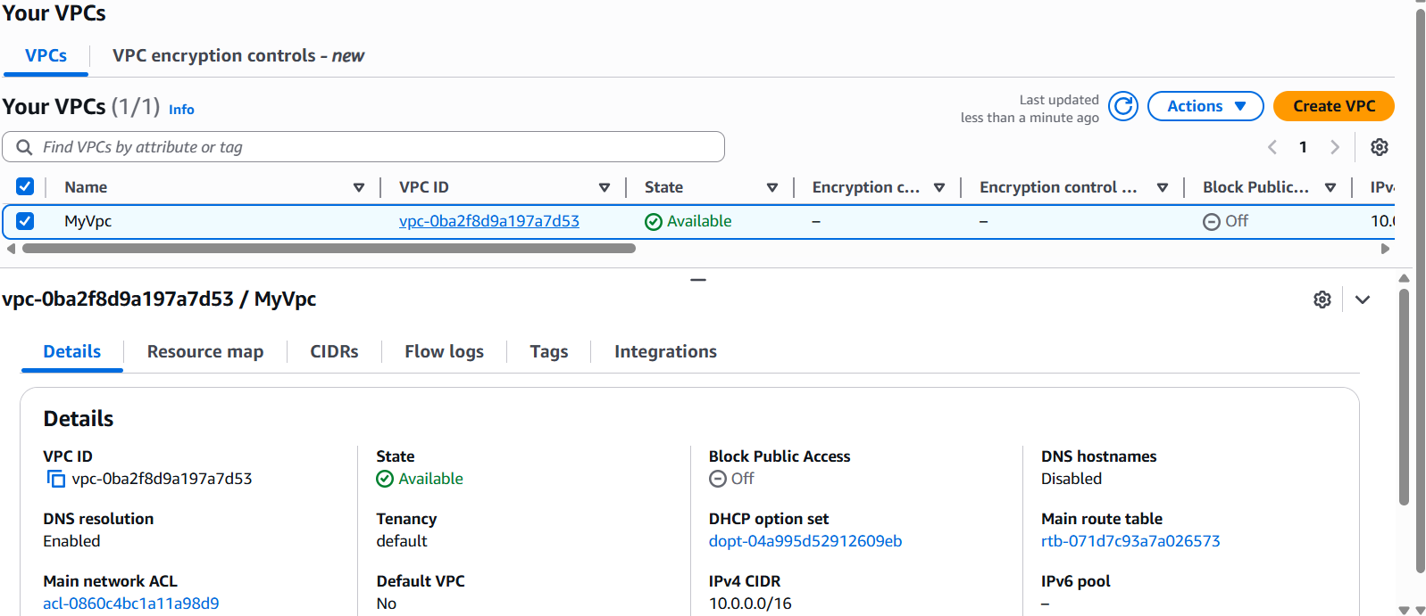
EC2 .
Amazon Elastic Compute Cloud (EC2) is a fundamental service within Amazon Web Services (AWS) that provides scalable and on-demand computing capacity in the cloud.
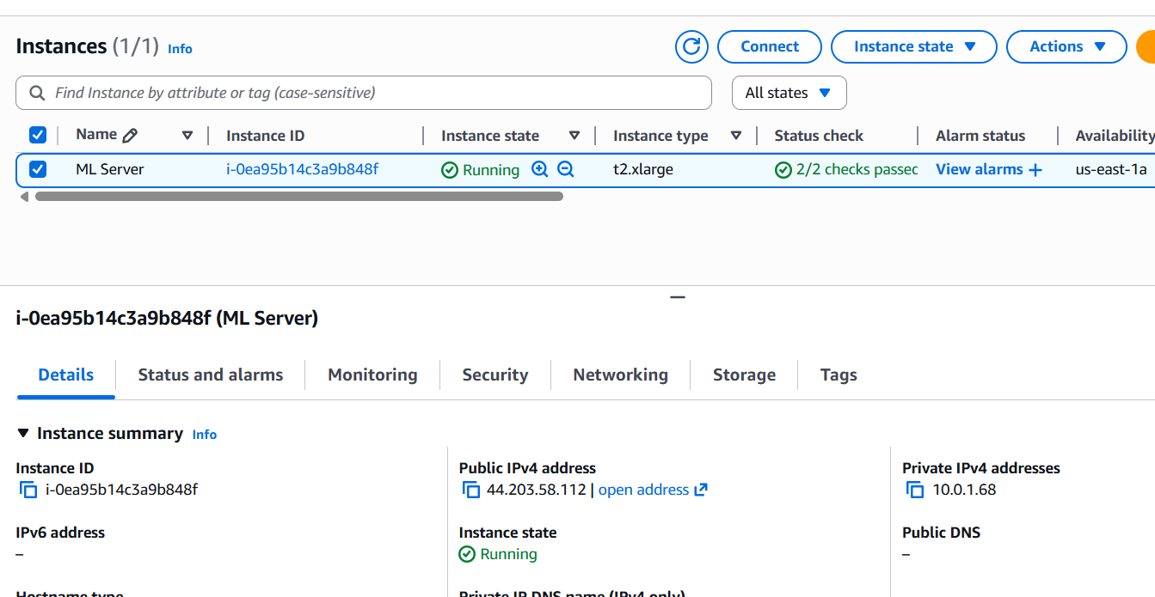
3. Project Structure
After setup, your folder should look like:
~/ml_project/
│
├─ data/ # Optional dataset folder
├─ venv/ # Python virtual environment
├─ ml_project/ # Optional subfolder for app files
├─ model.pkl # Initial pickle model (if exists)
├─ model.joblib # Joblib model (reliable)
├─ train.py # FastAPI server code
├─ create_model.py # Script to create & save model
├─ requirements.txt # Optional dependency file
2. Activate Virtual Environment.
#cd ~/ml_project
#source venv/bin/activate
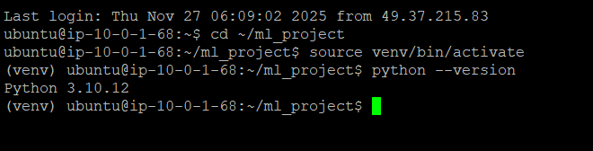
3. Install Dependencies.
#pip install fastapi uvicorn scikit-learn joblib pandas numpy pydantic
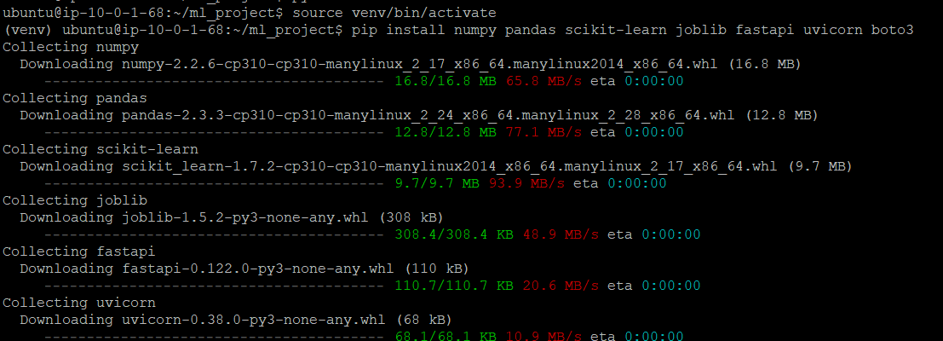
4. Create & Save Model.
Model.py.
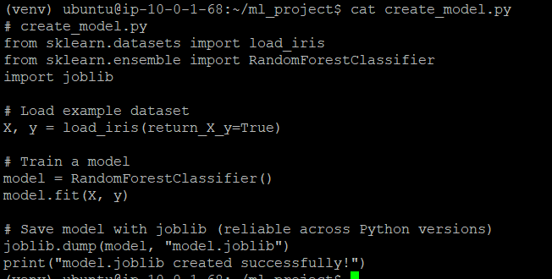
Run the script.
#python create_model.py.
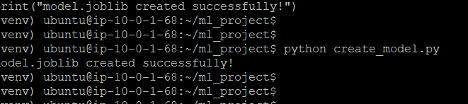
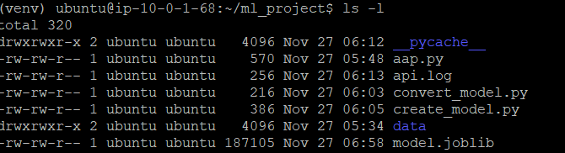
5. Fast Api (Train.py).
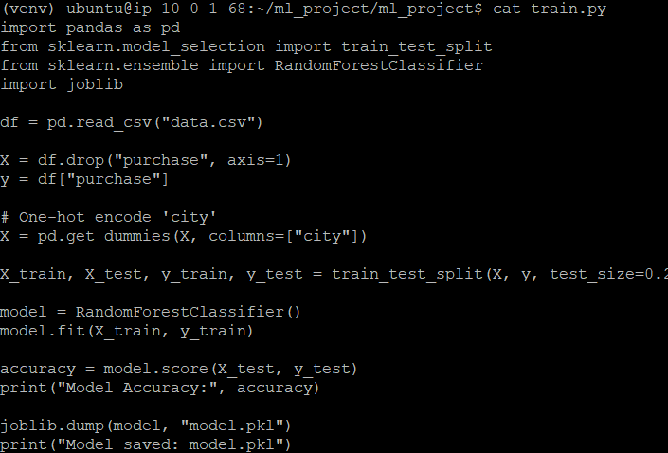
6.Run the Fast API Server.
#cd ~/ml_project
#uvicorn train:app --host 0.0.0.0 --port 8000
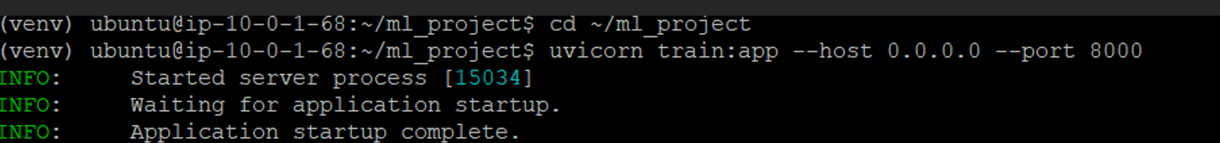
7.Test API.
Root check:
#curl http://127.0.0.1:8000/
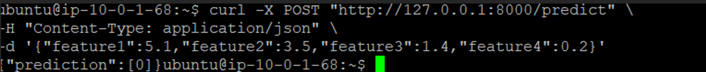
Prediction test:
#curl -X POST "http://127.0.0.1:8000/predict" \
-H "Content-Type: application/json" \
-d '{"feature1":5.1,"feature2":3.5,"feature3":1.4,"feature4":0.2}'
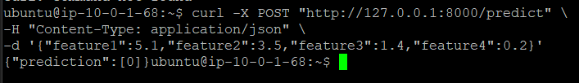
8.Logs.
All requests and predictions are logged in api.log:
#tail -f api.log.

